Name: Date:

A good way to learn spellings is to use a look / say /cover / write / check method. We need to do this several times for the word to stay in our memory. Use the grid below to help you to practise your spelling words each day.
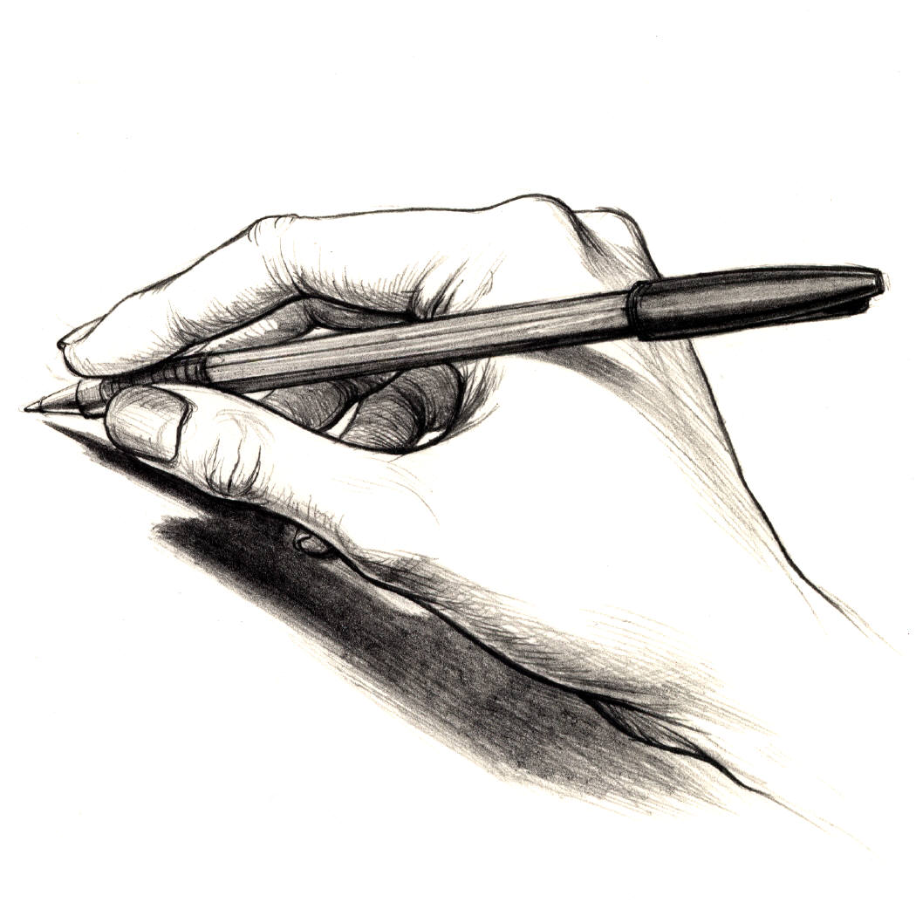
Spring 6
Remember: LOOK SAY COVER WRITE CHECK!
Spellings | Friday | Saturday | Sunday | Monday | Tuesday | Wednesday | Thursday
measure
treasure
pleasure
picture
creature
enclosure
nature
furniture
adventure
capture

Spellings | Friday | Saturday | Sunday | Monday | Tuesday | Wednesday | Thursday
Challenge words:
potatoes
pressure
probably
promise
purpose
Challenge word focus: Words from Year3/4 spelling list

Please bring this sheet with you on Friday to show how much you have practised!

