Name: Date:

A good way to learn spellings is to use a look / say /cover / write / check method. We need to do this several times for the word to stay in our memory. Use the grid below to help you to practise your spelling words each day.
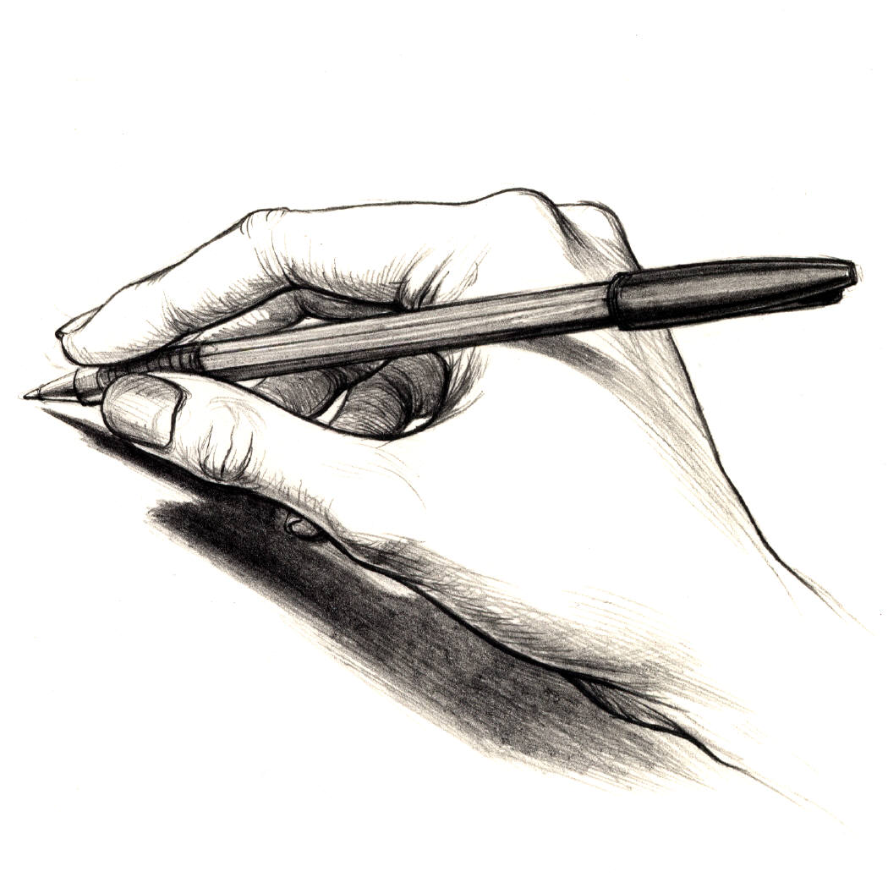
Autumn 10
Remember: LOOK SAY COVER WRITE CHECK!
Spellings | Friday | Saturday | Sunday | Monday | Tuesday | Wednesday | Thursday
musician
magician
politician
electrician
optician
mathematician
minute
heard
natural
peculiar

Spellings | Friday | Saturday | Sunday | Monday | Tuesday | Wednesday | Thursday
Challenge words:
heart
height
history
imagine
important
Challenge word focus: Words from Year3/4 spelling list

Please bring this sheet with you on Friday to show how much you have practised!

