Hello,

VIP Education is an Independent Education Welfare Support Service that is now working with your school to support Attendance, Punctuality and Welfare needs.

Our Staff have a wealth of experience supporting pupils and families. Regular visits and communication will take place at your child’s school to monitor every child’s school attendance.

If you feel you require support, you can ask your school to contact us.

Regular absences from school can affect:

* Attainment levels - the quality of schoolwork, qualifications gained
* School routine - disrupting your child’s learning and that of the other pupils
* The chances of children and young people being involved in anti-social behaviour
* A child or young person’s general wellbeing and long-term life opportunities

Improving regular attendance at school is therefore a key priority, both locally and nationally.

We are aware that children can miss school due to unavoidable illness. Please ensure that you communicate the reasons for your child’s absences on the first day of absence. If there are long-term attendance difficulties, then please discuss this with us so that we may support.

**Attendance is an important part of your Child's Education; they cannot learn if not in school.**

**Attendance = Attainment Everyday Counts!**

You are legally responsible for ensuring your child attends school every day and on time.

Persistent lateness can add up to many days' absence.

Please also be aware that if your child is late to school, after the register has closed, then this will be classed as an absence and further action could be taken against you

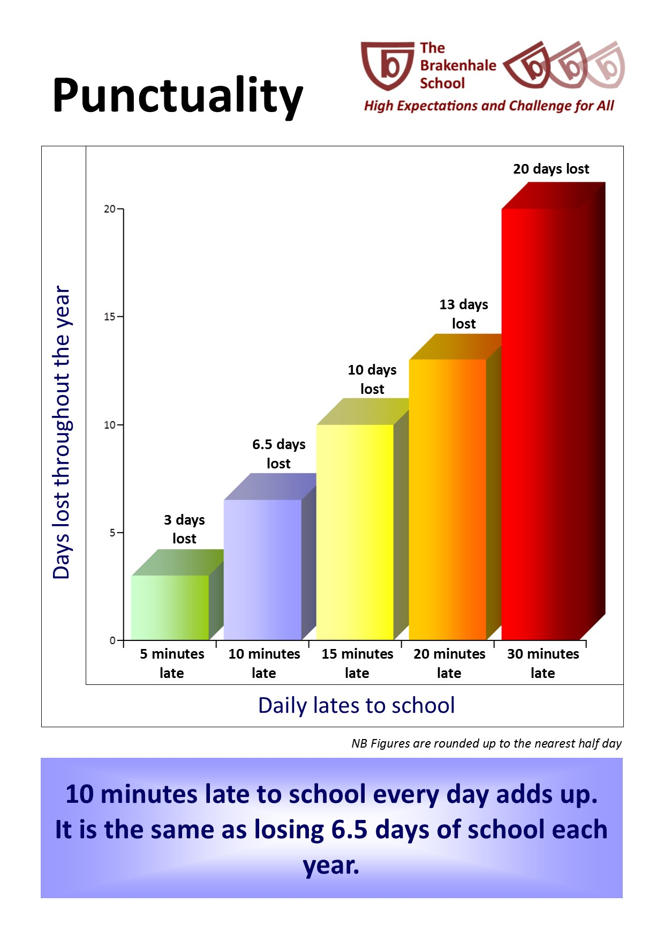

When a child arrives late at the start of the school day, it is very disruptive to their learning and the learning of their classmates

If you require any more Information about VIP Education, then contact your school.

Registered office: VIP Education Ltd. Stop Gap, Unit 1, Brindley Court, Dalewood Road, Chesterton, Staffordshire. ST5 9QA. Company Registration Number: 12497086